Software Design Document (SDD)
Lab Assignment 04: UART
UART Driver — STM32F411RE
Module | UART Driver
Version | 1.0.0
Author | Sebastian Lizalde Herrera, Michelle Urbina Carlos, Melanie Picen Hernández
Date | 14/05/2026
Institution | CETYS Universidad

- Introduction

  - Purpose

This document describes the design and architecture of the UART driver module, based on the requirements defined in the SRS. It provides details on data structures, algorithms, and control flow to guide implementation and testing of the UART peripheral driver for the STM32F411RE microcontroller.
  - Scope

The UART driver is a low-level bare-metal software component for the STM32F411RE embedded system. It abstracts hardware registers and provides a clean API for higher-level modules to perform asynchronous serial communication via the USART2 peripheral. The driver supports baud rate configuration based on the system clock and polling-based byte transmission.
  - Definitions and Acronyms

Term | Definition
USART | Universal Synchronous Asynchronous Receiver Transmitter — serial communication peripheral on the STM32F411RE.
UART | Universal Asynchronous Receiver Transmitter — asynchronous-only operating mode of the USART peripheral.
Baud Rate | Speed of serial communication expressed in bits per second (bps).
TXE | Transmit Data Register Empty flag — bit 7 of USART_SR. Set when the DR register is ready to accept a new byte.
TE | Transmitter Enable — bit 3 of USART_CR1. Must be set to activate the USART transmitter.
UE | USART Enable — bit 13 of USART_CR1. Enables the USART peripheral.
BRR | Baud Rate Register — stores the integer divisor for baud rate generation (USARTDIV = fCK / baudrate).
APB1 | Advanced Peripheral Bus 1 — the bus on which USART2 is clocked (RM0383 section 2.3).
AF7 | Alternate Function 7 — the GPIO alternate function that connects PA2/PA3 to USART2 TX/RX.
VCP | Virtual COM Port — the ST-LINK USB CDC interface that exposes USART2 as a serial port on the host PC.
SRS | Software Requirements Specification.
SDD | Software Design Document.
FR | Functional Requirement.
HAL | Hardware Abstraction Layer — not used in this driver.

  - Requirements

All requirements specific to this module are allocated in the UART Driver SRS (Version 1.0, Author: Carlos Villarreal, CETYS Universidad). The SRS defines functional requirements FR-1 through FR-5 and non-functional requirements NFR-1 through NFR-2, which this document addresses through the design described herein.
- System Architecture

2.1. High-Level Design

The UART driver follows a layered architecture pattern separating application logic from hardware access:
- Application Layer: Calls UART driver functions (uart_init, uart_write) to perform serial communication without any knowledge of hardware registers.
- UART Driver Layer: Provides the public API defined in UART_Driver.h. Implements all logic including parameter validation, GPIO configuration, clock enabling, baud rate calculation, and polling-based transmission.
- Hardware Layer: The actual STM32F411RE USART2 hardware registers accessed directly through the memory-mapped USART_RegDef_t structure at base address 0x40004400. RCC registers are accessed via RCC_UART_RegDef_t at 0x40023800.

  - Module Interfaces

- Public API: All user-facing functions are declared in UART_Driver.h. The header also exposes the USART_RegDef_t and RCC_UART_RegDef_t register map structures, the UART_Status_t error enumeration, and constants such as UART_SYSTEM_CLOCK_HZ and UART_DEFAULT_BAUDRATE.
- Dependencies: The UART driver depends on GPIO_stm32f4.h and its driver functions (gpio_initPort, gpio_setPinMode, gpio_setAlternateFunction) to configure PA2 and PA3 in Alternate Function 7 mode before enabling USART2. stdint.h is required for fixed-width integer types.
- Detailed Design

3.1. Class Diagram
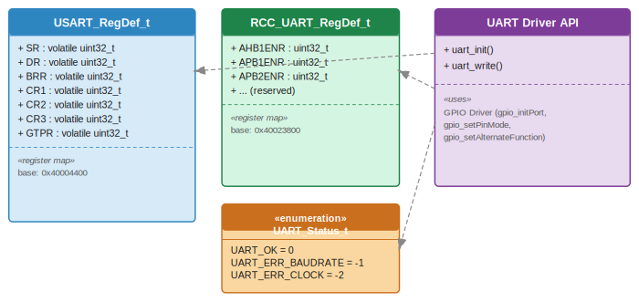
Figure 1. Class Diagram — UART Driver

  - Module Behavior

3.2.1. Sequence Diagram — uart_init
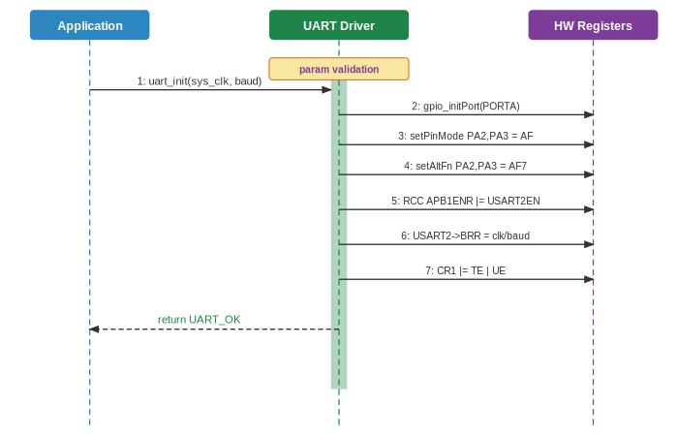
Figure 2. Sequence Diagram — uart_init
3.2.2. Activity Diagram — uart_init
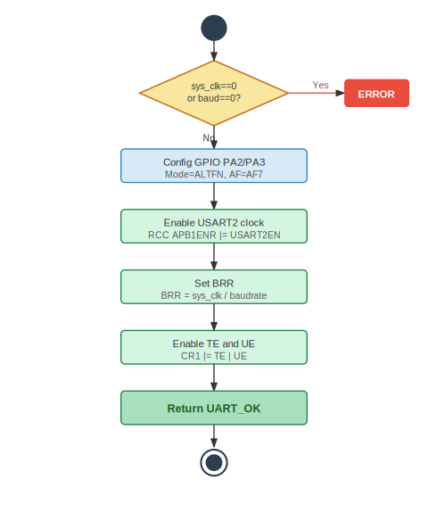
Figure 3. Activity Diagram — uart_init

3.2.3. Sequence Diagram — uart_init with Conditional
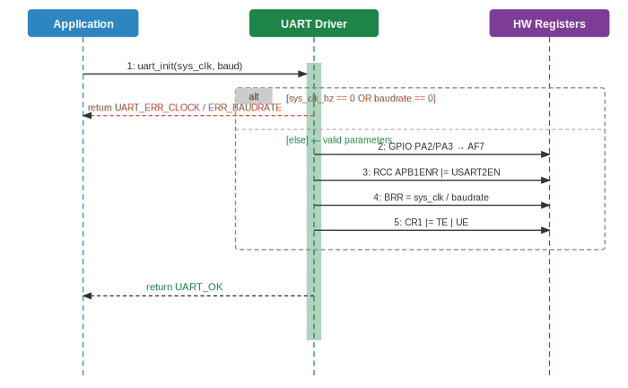
Figure 4. Sequence Diagram — uart_init with Conditional
3.2.4. Activity Diagram — uart_init with Conditional
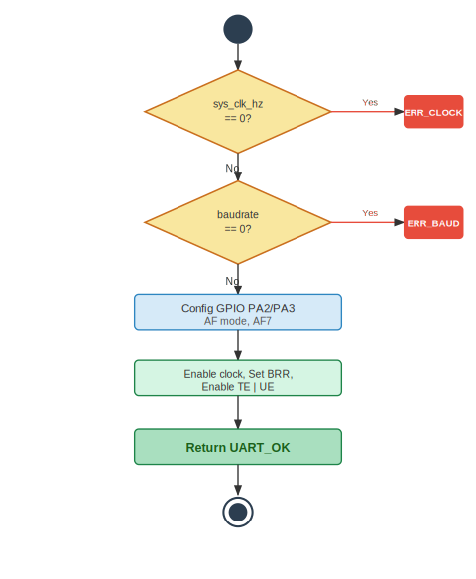
Figure 5. Activity Diagram — uart_init with Conditional

3.2.5. Sequence Diagram — uart_write (Loop)
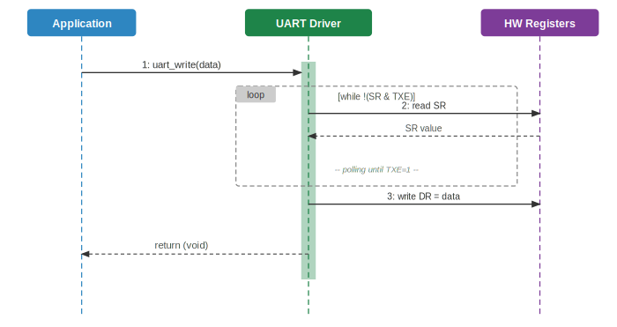
Figure 6. Sequence Diagram — uart_write with Loop
3.2.6. Activity Diagram — uart_write (Loop)
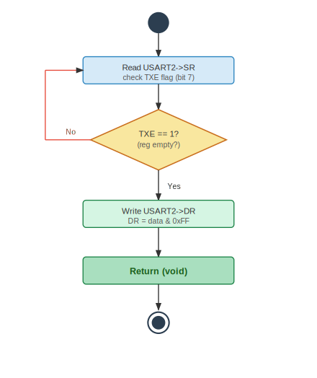
Figure 7. Activity Diagram — uart_write with Loop

3.2.7. State Diagram — UART Driver
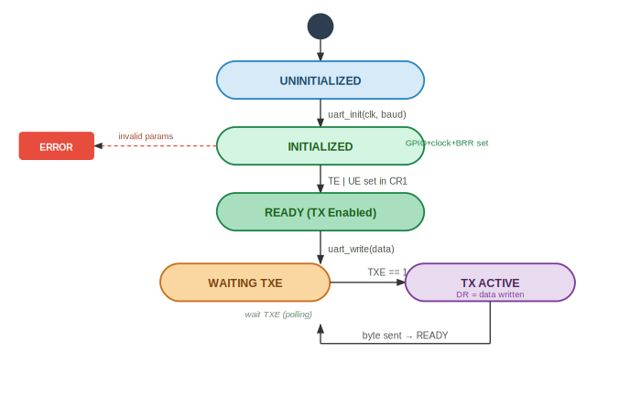
Figure 8. State Diagram — UART Driver
  - UART Driver

The UART driver is a stateless, bare-metal C module that directly configures and reads the STM32F411RE USART2 peripheral through memory-mapped registers, as specified in RM0383.
Initialization (FR-1, FR-2, FR-3): The uart_init function begins by validating both input parameters. If sys_clk_hz is zero, it returns UART_ERR_CLOCK immediately; if baudrate is zero, it returns UART_ERR_BAUDRATE. This conditional validation is illustrated in Figures 4 and 5. Otherwise, it calls gpio_initPort to enable the GPIOA clock, then configures PA2 (TX) and PA3 (RX) as Alternate Function mode using gpio_setPinMode, and maps them to AF7 via gpio_setAlternateFunction — the function that connects those GPIO pins to USART2 on the STM32F411RE (datasheet Table 9). Next, it enables the USART2 peripheral clock by setting bit 17 of RCC->APB1ENR (FR-1). The baud rate register is then set to sys_clk_hz / baudrate, which produces the correct USARTDIV value for 16x oversampling (FR-2); for example, 16 000 000 / 115 200 = 138 yields an actual baud rate of ~115 200 bps. Finally, TE (Transmitter Enable) and UE (USART Enable) bits are set in CR1 (FR-3). The complete initialization flow is shown in Figures 2 and 3.
Transmission (FR-4, FR-5): uart_write polls the TXE flag (bit 7) in the USART_SR register in a blocking loop until the transmit data register is empty (FR-4). Once TXE is set — meaning the hardware shift register has accepted the previous byte — the new byte is written to USART_DR masked to 8 bits (FR-5). The polling ensures that writes never overwrite data that has not yet been transferred to the shift register, satisfying the SRS Section 2.3 constraint. This behavior is shown in Figures 6 and 7.
The state diagram (Figure 8) shows the full driver lifecycle: from UNINITIALIZED, through INITIALIZED (GPIO and clock configured), to READY (TX enabled via TE and UE). When uart_write is called, the driver enters WAITING TXE (polling loop), transitions to TX ACTIVE once TXE=1 and the byte is written, then returns to READY automatically. Invalid parameters during init lead directly to an ERROR terminal state.
- Application Programming Interfaces

4.1. Data Types and Macros

Data Types

- UART_Status_t: This enumeration represents the return status of all public UART driver functions. It allows callers to detect and handle errors without inspecting hardware registers directly.
Member Name | Type / Value
UART_OK | 0 — Operation completed successfully.
UART_ERR_BAUDRATE | -1 — The baudrate parameter provided is zero.
UART_ERR_CLOCK | -2 — The sys_clk_hz parameter provided is zero.

- USART_RegDef_t: This structure is a direct memory-mapped overlay of the STM32F411RE USART2 peripheral registers (RM0383 Section 19.6). It is instantiated by pointing to the USART2 base address (0x40004400UL).
Member Name | Type | Notes / Definition
SR | volatile uint32_t | Status Register. Holds TXE (bit 7), TC (bit 6), RXNE (bit 5). Offset: 0x00.
DR | volatile uint32_t | Data Register. Write transmits a byte; read receives a byte. Offset: 0x04.
BRR | volatile uint32_t | Baud Rate Register. BRR = fCK / baudrate for 16x oversampling. Offset: 0x08.
CR1 | volatile uint32_t | Control Register 1. UE (bit 13), TE (bit 3), RE (bit 2). Offset: 0x0C.
CR2 | volatile uint32_t | Control Register 2. Stop bits configuration. Offset: 0x10.
CR3 | volatile uint32_t | Control Register 3. Hardware flow control. Offset: 0x14.
GTPR | volatile uint32_t | Guard Time and Prescaler Register. Offset: 0x18.

- RCC_UART_RegDef_t: This structure maps the full STM32F411RE RCC register block at base address 0x40023800UL. It exposes APB1ENR at offset 0x40, which contains the USART2EN clock enable bit.
Member Name | Type | Notes / Definition
CR | volatile uint32_t | Clock Control Register. Offset: 0x00.
PLLCFGR | volatile uint32_t | PLL Configuration Register. Offset: 0x04.
AHB1ENR | volatile uint32_t | AHB1 peripheral clock enable (GPIO clocks). Offset: 0x30.
APB1ENR | volatile uint32_t | APB1 peripheral clock enable. Bit 17 = USART2EN. Offset: 0x40.
APB2ENR | volatile uint32_t | APB2 peripheral clock enable. Offset: 0x44.

Macros
- USART2_BASE: This USART2_BASE represents the base address of the USART2 peripheral in the STM32F411RE memory map (APB1 bus, RM0383 section 2.3). The USART2_BASE value is 0x40004400UL.
- RCC_FULL_BASE: This RCC_FULL_BASE represents the base address of the RCC register block in the STM32F411RE memory map. The RCC_FULL_BASE value is 0x40023800UL.
- RCC_APB1ENR_USART2EN: This RCC_APB1ENR_USART2EN represents the clock enable bit for the USART2 peripheral within RCC_APB1ENR (RM0383 section 6.3.11). The RCC_APB1ENR_USART2EN value is 1U << 17.
- USART_SR_TXE: This USART_SR_TXE represents the Transmit Data Register Empty flag in USART_SR, used in uart_write to verify readiness before writing. The USART_SR_TXE value is 1U << 7.
- USART_CR1_UE: This USART_CR1_UE represents the USART Enable bit in USART_CR1, set during uart_init to activate the peripheral. The USART_CR1_UE value is 1U << 13.
- USART_CR1_TE: This USART_CR1_TE represents the Transmitter Enable bit in USART_CR1, set during uart_init to activate the transmitter. The USART_CR1_TE value is 1U << 3.
- UART_SYSTEM_CLOCK_HZ: This UART_SYSTEM_CLOCK_HZ represents the default HSI clock frequency, used as the sys_clk_hz argument when no external oscillator is configured. The UART_SYSTEM_CLOCK_HZ value is 16000000UL.
- UART_DEFAULT_BAUDRATE: This UART_DEFAULT_BAUDRATE represents the default baud rate matching the ST-LINK Virtual COM Port configuration on the NUCLEO-F411RE board. The UART_DEFAULT_BAUDRATE value is 115200UL.

  - Error Codes

All public UART driver functions that return UART_Status_t use the following error codes.
Code | Notes / Definition
UART_OK (0) | Operation was successful. The requested action was performed without errors.
UART_ERR_BAUDRATE (-1) | The baudrate parameter passed to uart_init is zero. No peripheral configuration is performed.
UART_ERR_CLOCK (-2) | The sys_clk_hz parameter passed to uart_init is zero. No peripheral configuration is performed.

  - Function Definitions

uart_init

Function Name | uart_init
Syntax | UART_Status_t uart_init(uint32_t sys_clk_hz, uint32_t baudrate)
Parameters (in) | sys_clk_hz — System clock frequency in Hz (e.g. 16000000UL for HSI).  baudrate — Desired baud rate in bps (e.g. 115200UL).
Parameters (inout) | None.
Parameters (out) | None.
Return value | UART_Status_t — Returns UART_OK (0) on success. Returns UART_ERR_CLOCK (-2) if sys_clk_hz is zero. Returns UART_ERR_BAUDRATE (-1) if baudrate is zero.
Description | Configures GPIO PA2 (TX) and PA3 (RX) as AF7 using the GPIO driver. Enables the USART2 APB1 clock via RCC->APB1ENR bit 17 (FR-1). Sets BRR = sys_clk_hz / baudrate for 16x oversampling (FR-2). Enables the transmitter (TE) and USART peripheral (UE) in CR1 (FR-3).
Constraints | The GPIO driver must be available and its gpio_initPort, gpio_setPinMode, and gpio_setAlternateFunction functions must be functional before calling uart_init. This function does not configure NVIC interrupts; only polling-based TX is supported.
Available via | UART_Driver.h

uart_write

Function Name | uart_write
Syntax | void uart_write(uint8_t data)
Parameters (in) | data — The 8-bit byte to transmit over USART2.
Parameters (inout) | None.
Parameters (out) | None.
Return value | void — No return value.
Description | Polls the TXE flag (bit 7) in USART2->SR in a blocking loop until the transmit data register is empty (FR-4). Once TXE is set, writes the byte masked to 8 bits into USART2->DR to initiate transmission (FR-5). Complies with the SRS Section 2.3 constraint that the hardware TXE flag must be checked before writing to the data register.
Constraints | This function is blocking; it will loop indefinitely if the TXE flag never becomes set due to hardware failure. No timeout mechanism is implemented. uart_init must be called successfully before calling uart_write.
Available via | UART_Driver.h

  - Internal Function Definitions

The UART driver v1.0 has no internal (static) helper functions. All logic is contained directly within the two public functions uart_init and uart_write.
- Future Enhancements

- Interrupt-driven transmission: Add TXEIE interrupt configuration in CR1 to allow non-blocking byte transmission via ISR, eliminating the busy-wait loop in uart_write.
- Receive support: Implement uart_read using the RXNE flag (bit 5 of SR) and RE bit in CR1 to enable full-duplex communication.
- Timeout mechanism: Add a maximum iteration count to the TXE polling loop in uart_write to prevent indefinite blocking in case of hardware failure.
- DMA support: Implement DMA-based data transfer for continuous string transmission to allow non-blocking UART operation at high baud rates.
- Configurable word length and parity: Expose CR1 M (word length) and PCE/PS (parity) fields in the uart_init API for 9-bit frames or parity-enabled communication.
- Configurable stop bits: Expose the CR2 STOP[1:0] field to allow 0.5, 1, 1.5, or 2 stop bits as required by the target device.
- Multi-instance support: Extend the driver to support USART1 and USART6 (APB2) in addition to USART2, using a uart_config_t structure to pass the peripheral base address and GPIO pin mapping.
- String transmission helper: Add a uart_writeString(const char *str) function that calls uart_write in a loop, to simplify the Serial module implementation.

